Circular–Freeform Closed Shapes
# Source: AI Source: Provided by: [Data Path: Persons Table -> ID Column: 1, Name_En Column: Motasem Essam] -> From: [ChatGPT] on [7/25/2026]
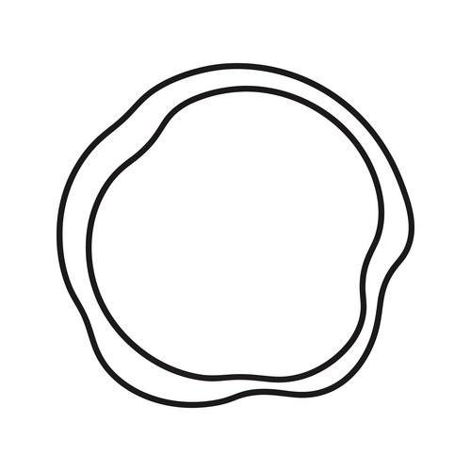
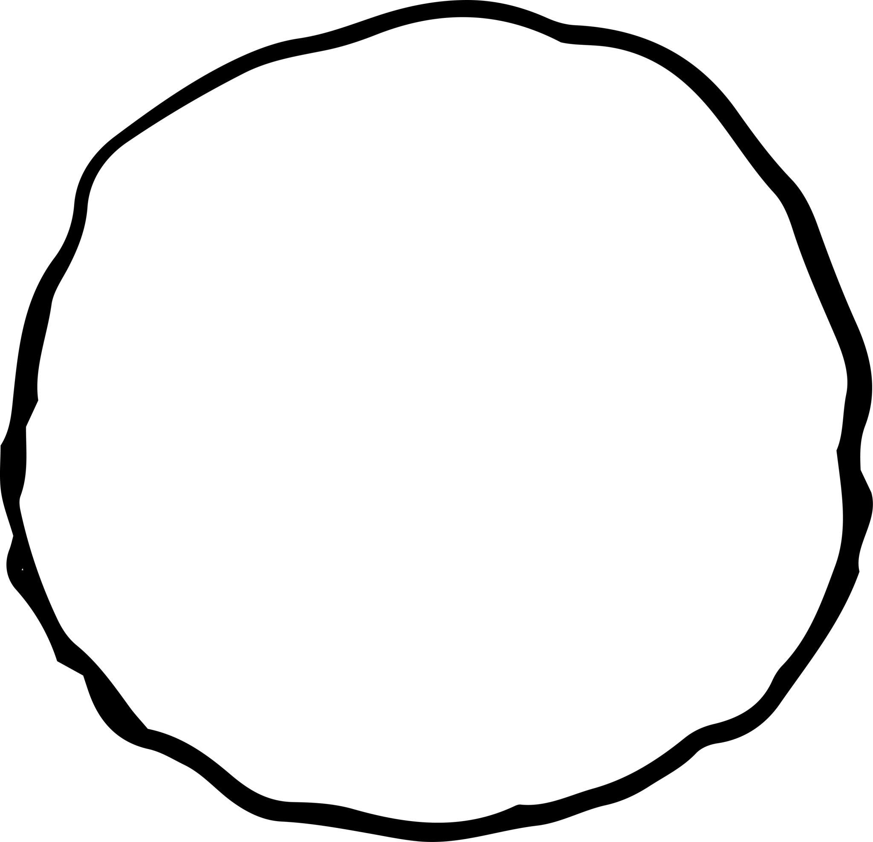
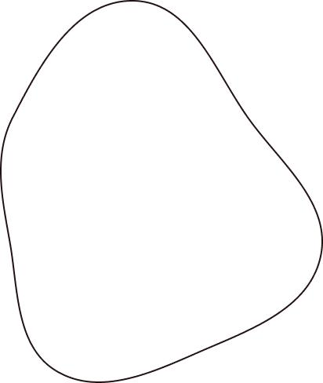
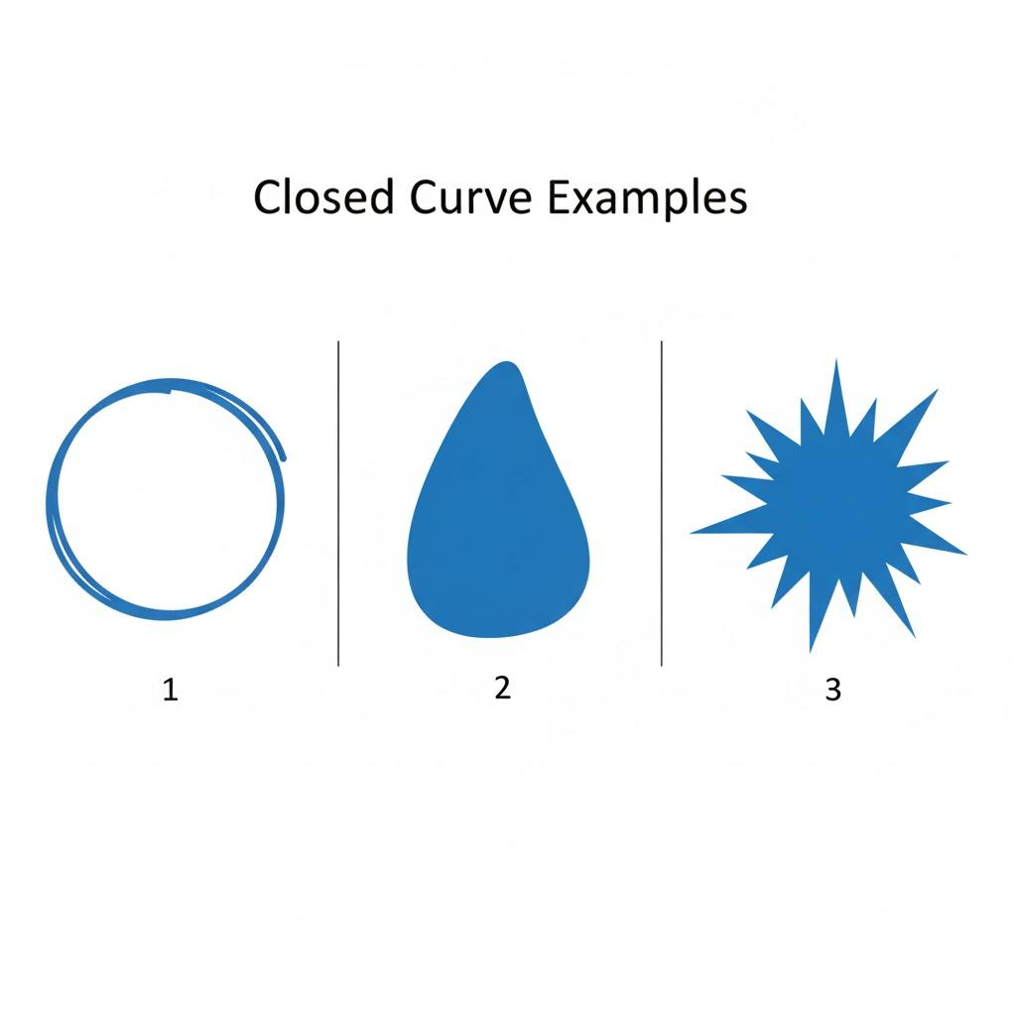
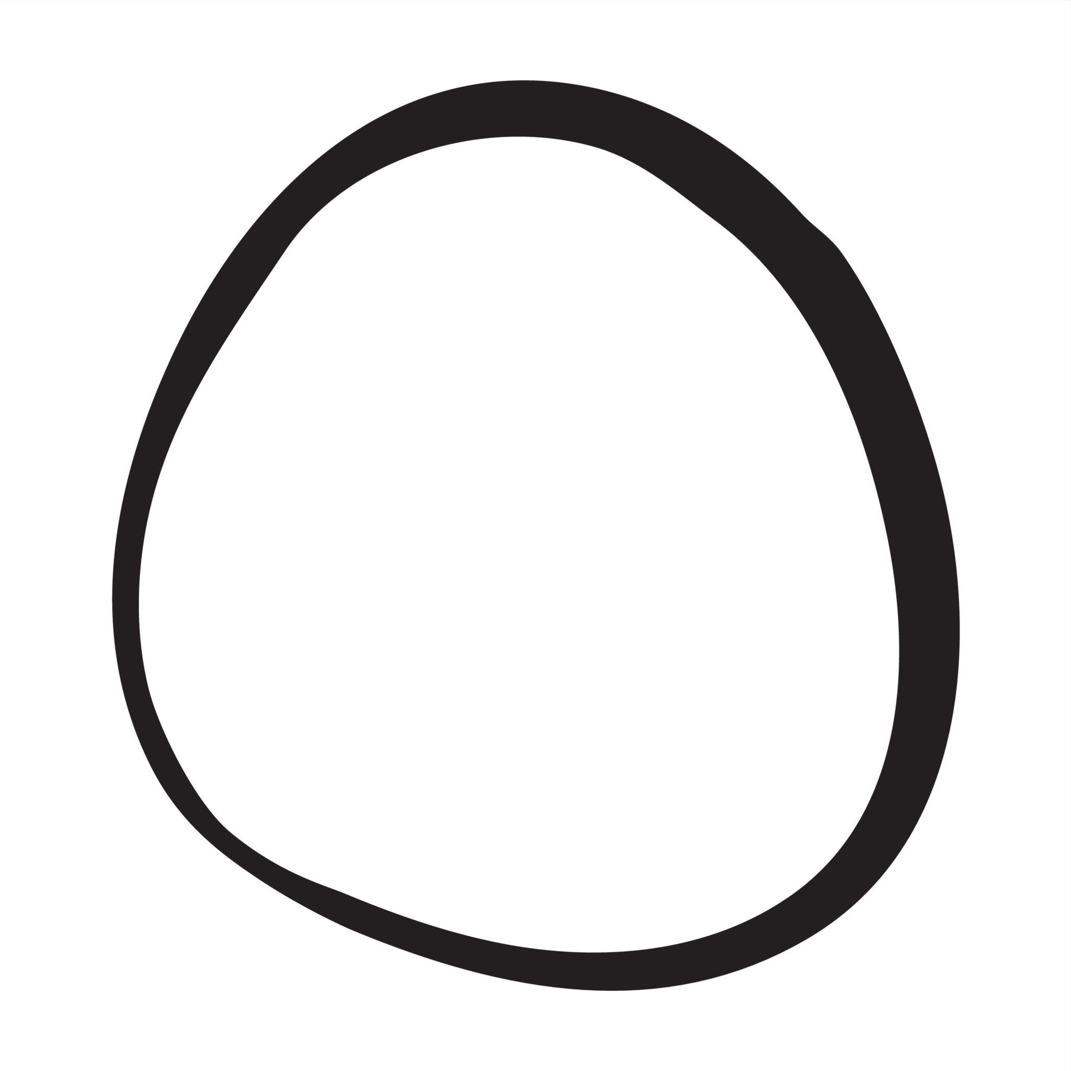

Definition
# Source: AI Source: Provided by: [Data Path: Persons Table -> ID Column: 1, Name_En Column: Motasem Essam] -> From: [ChatGPT] on [7/25/2026]
A Circular–Freeform Closed Shape is a closed mixed shape whose boundary combines one or more circular components with freely designed curved portions.
$$\boxed{\text{Circular–Freeform Closed Shape}=\text{Circular Component}+\text{Freeform Curves}+\text{Closed Boundary}}$$
The key idea is that the shape contains recognizable circular geometry, while another part of the boundary is freely designed rather than restricted to a standard geometric curve.

Characteristics
# Source: AI Source: Provided by: [Data Path: Persons Table -> ID Column: 1, Name_En Column: Motasem Essam] -> From: [ChatGPT] on [7/25/2026]
A Circular–Freeform Closed Shape typically:
- Is closed.
- Encloses a bounded region.
- Contains at least one circular arc or circular portion.
- Contains at least one freeform curved portion.
- Has no requirement for the freeform portion to follow a circle or ellipse.
- May be symmetric or asymmetric.
- May be regular-looking or irregular.
- May contain smooth or variable curvature.
- Can be constructed using Bézier curves, splines, CAD paths, or freehand curves.

Types of Circular–Freeform Closed Shapes

1. Circle–Freeform Arc Closed Shapes
# Source: AI Source: Provided by: [Data Path: Persons Table -> ID Column: 1, Name_En Column: Motasem Essam] -> From: [ChatGPT] on [7/25/2026]
A circular arc is connected to one or more freely designed curves to create a closed boundary.
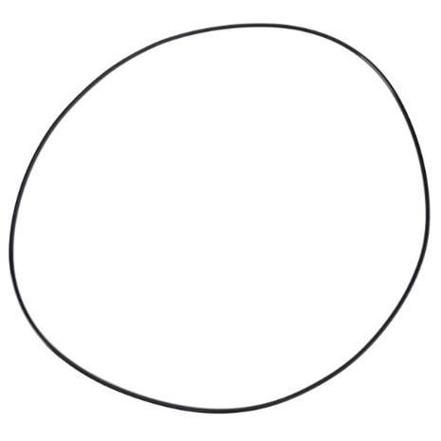
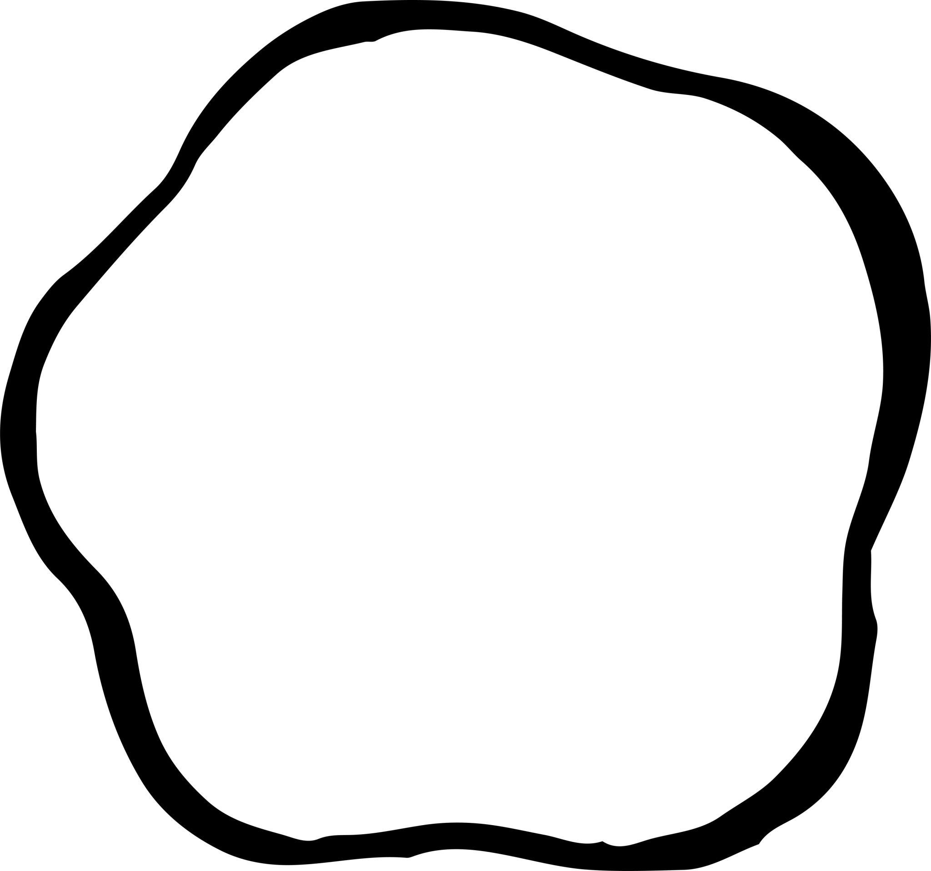
$$\boxed{\text{Circular Arc}+\text{Freeform Curve}}$$

2. Circle–Bézier Closed Shapes
# Source: AI Source: Provided by: [Data Path: Persons Table -> ID Column: 1, Name_En Column: Motasem Essam] -> From: [ChatGPT] on [7/25/2026]
A circular portion is combined with Bézier curve segments.
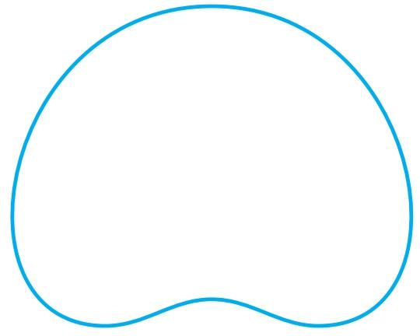
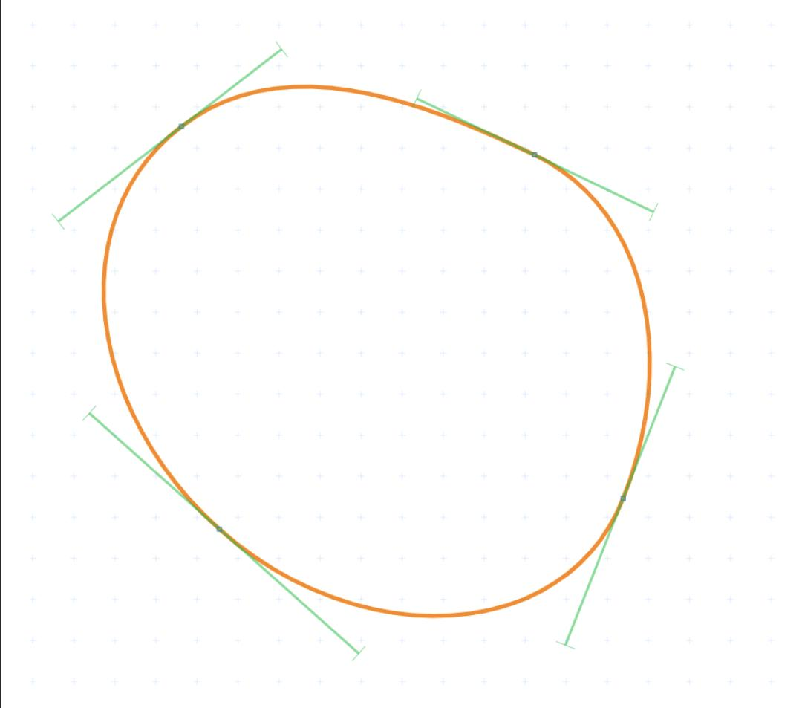
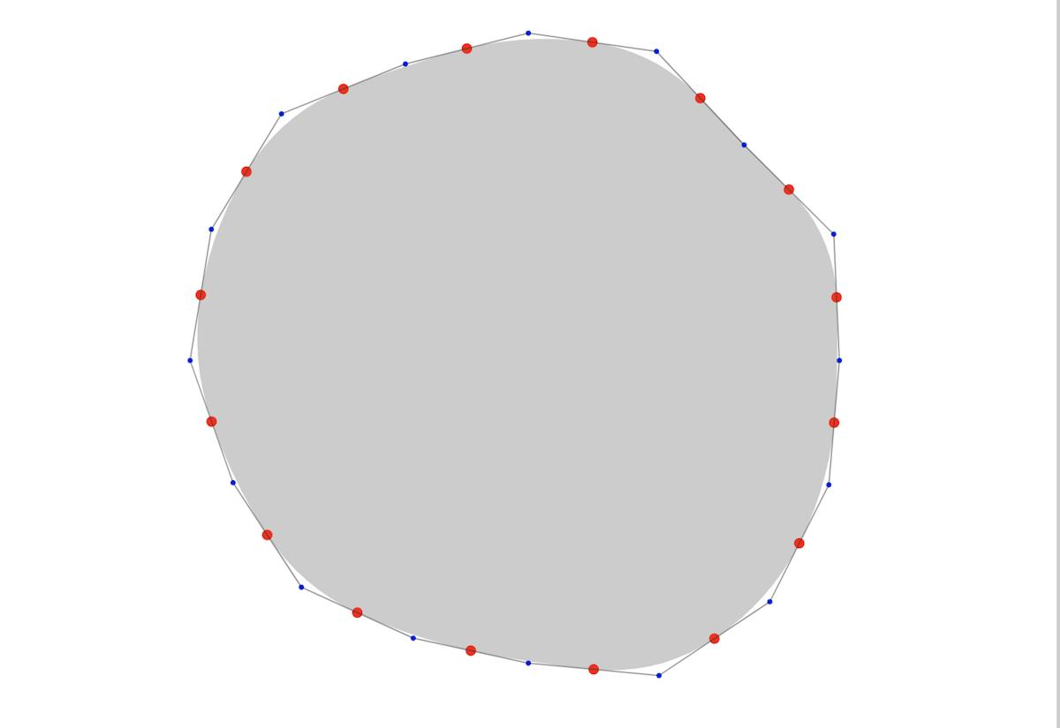
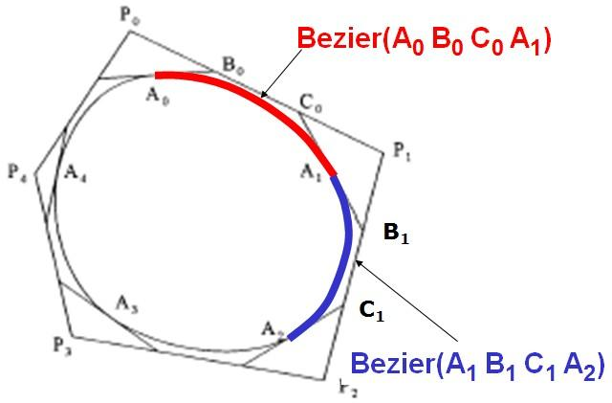
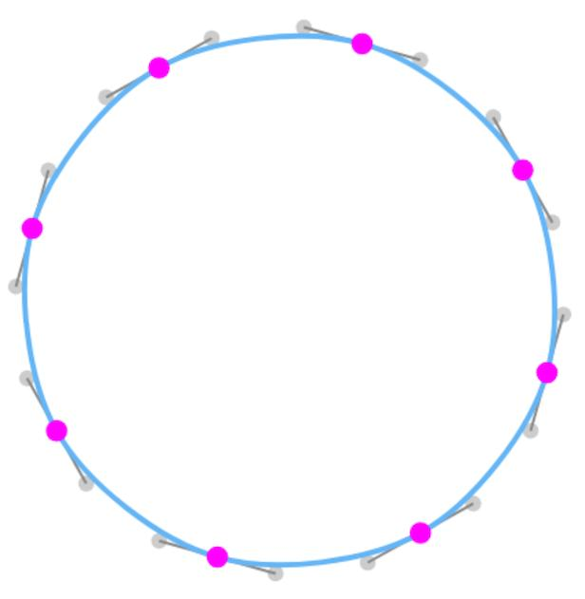
The Bézier portion can have continuously changing curvature.
A cubic Bézier segment can be represented as:
$$B\left(t\right)={\left(1-t\right)}^{3}P_{0}+3{\left(1-t\right)}^{2}tP_{1}+3\left(1-t\right)t^{2}P_{2}+t^{3}P_{3}$$

3. Circle–Spline Closed Shapes
# Source: AI Source: Provided by: [Data Path: Persons Table -> ID Column: 1, Name_En Column: Motasem Essam] -> From: [ChatGPT] on [7/25/2026]
A circular component is combined with spline-based curves.
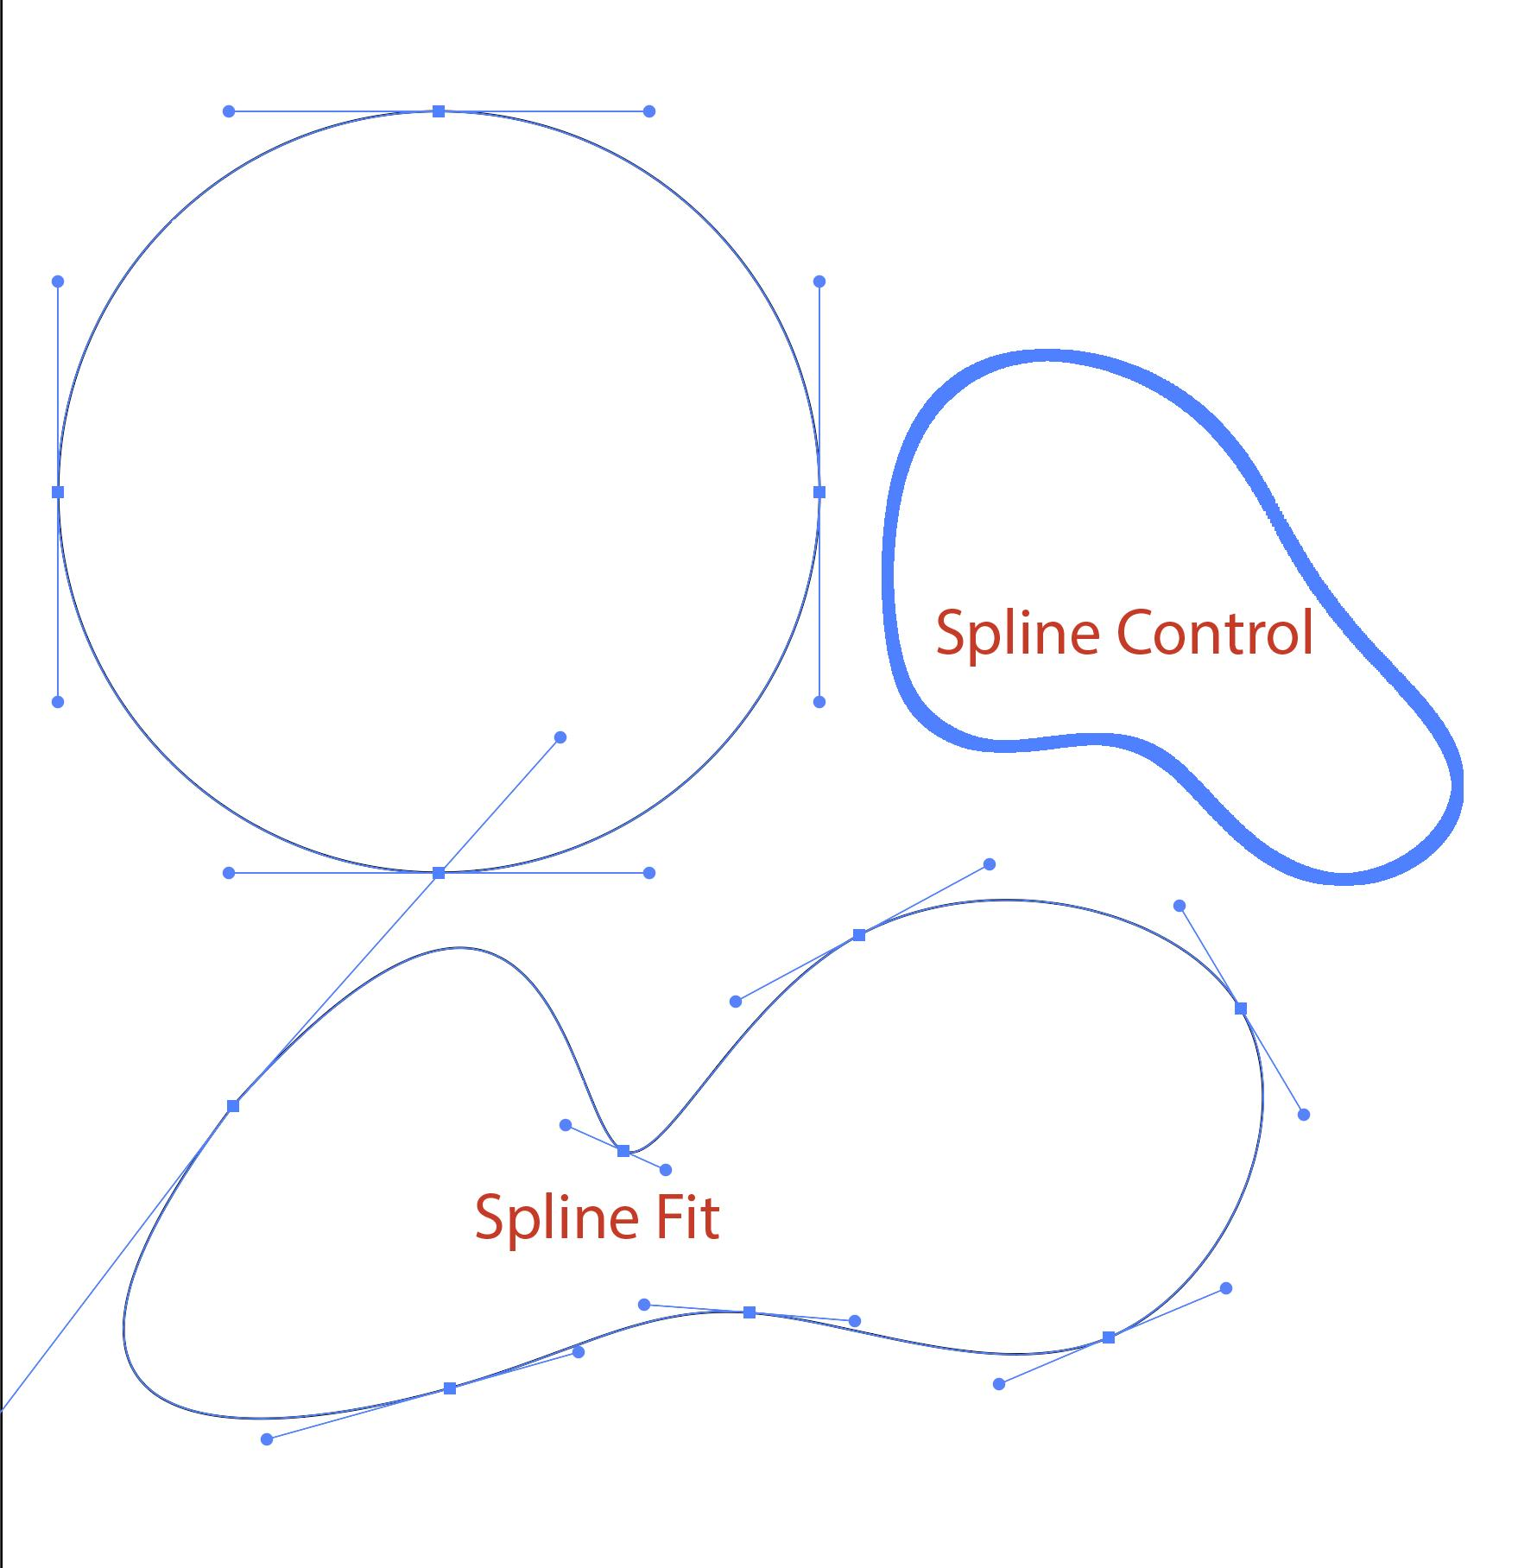
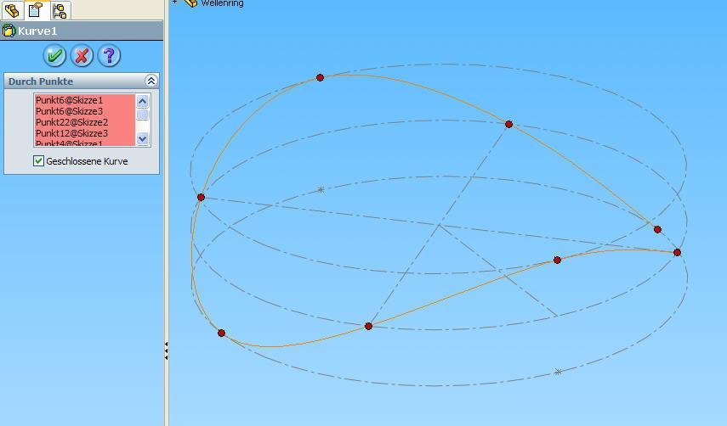
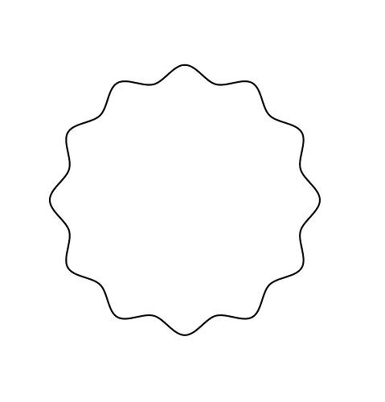
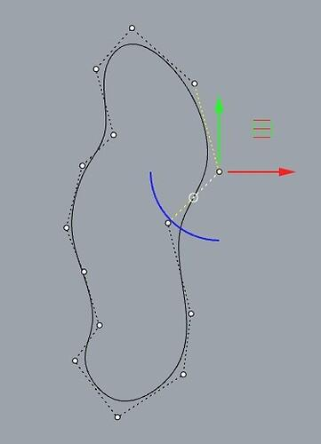
Spline curves are useful when the freeform section needs smooth transitions between several control points.

4. Circle–Wavy Freeform Closed Shapes
# Source: AI Source: Provided by: [Data Path: Persons Table -> ID Column: 1, Name_En Column: Motasem Essam] -> From: [ChatGPT] on [7/25/2026]
A circular portion is combined with a freely designed wavy boundary.
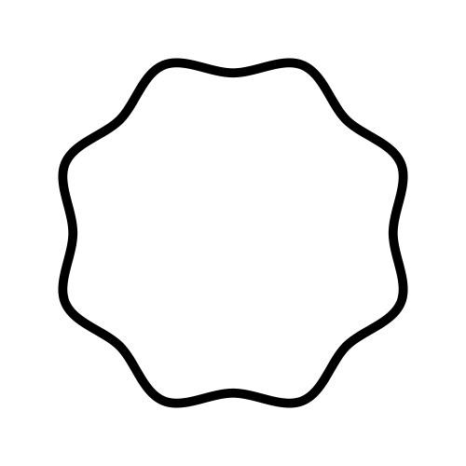
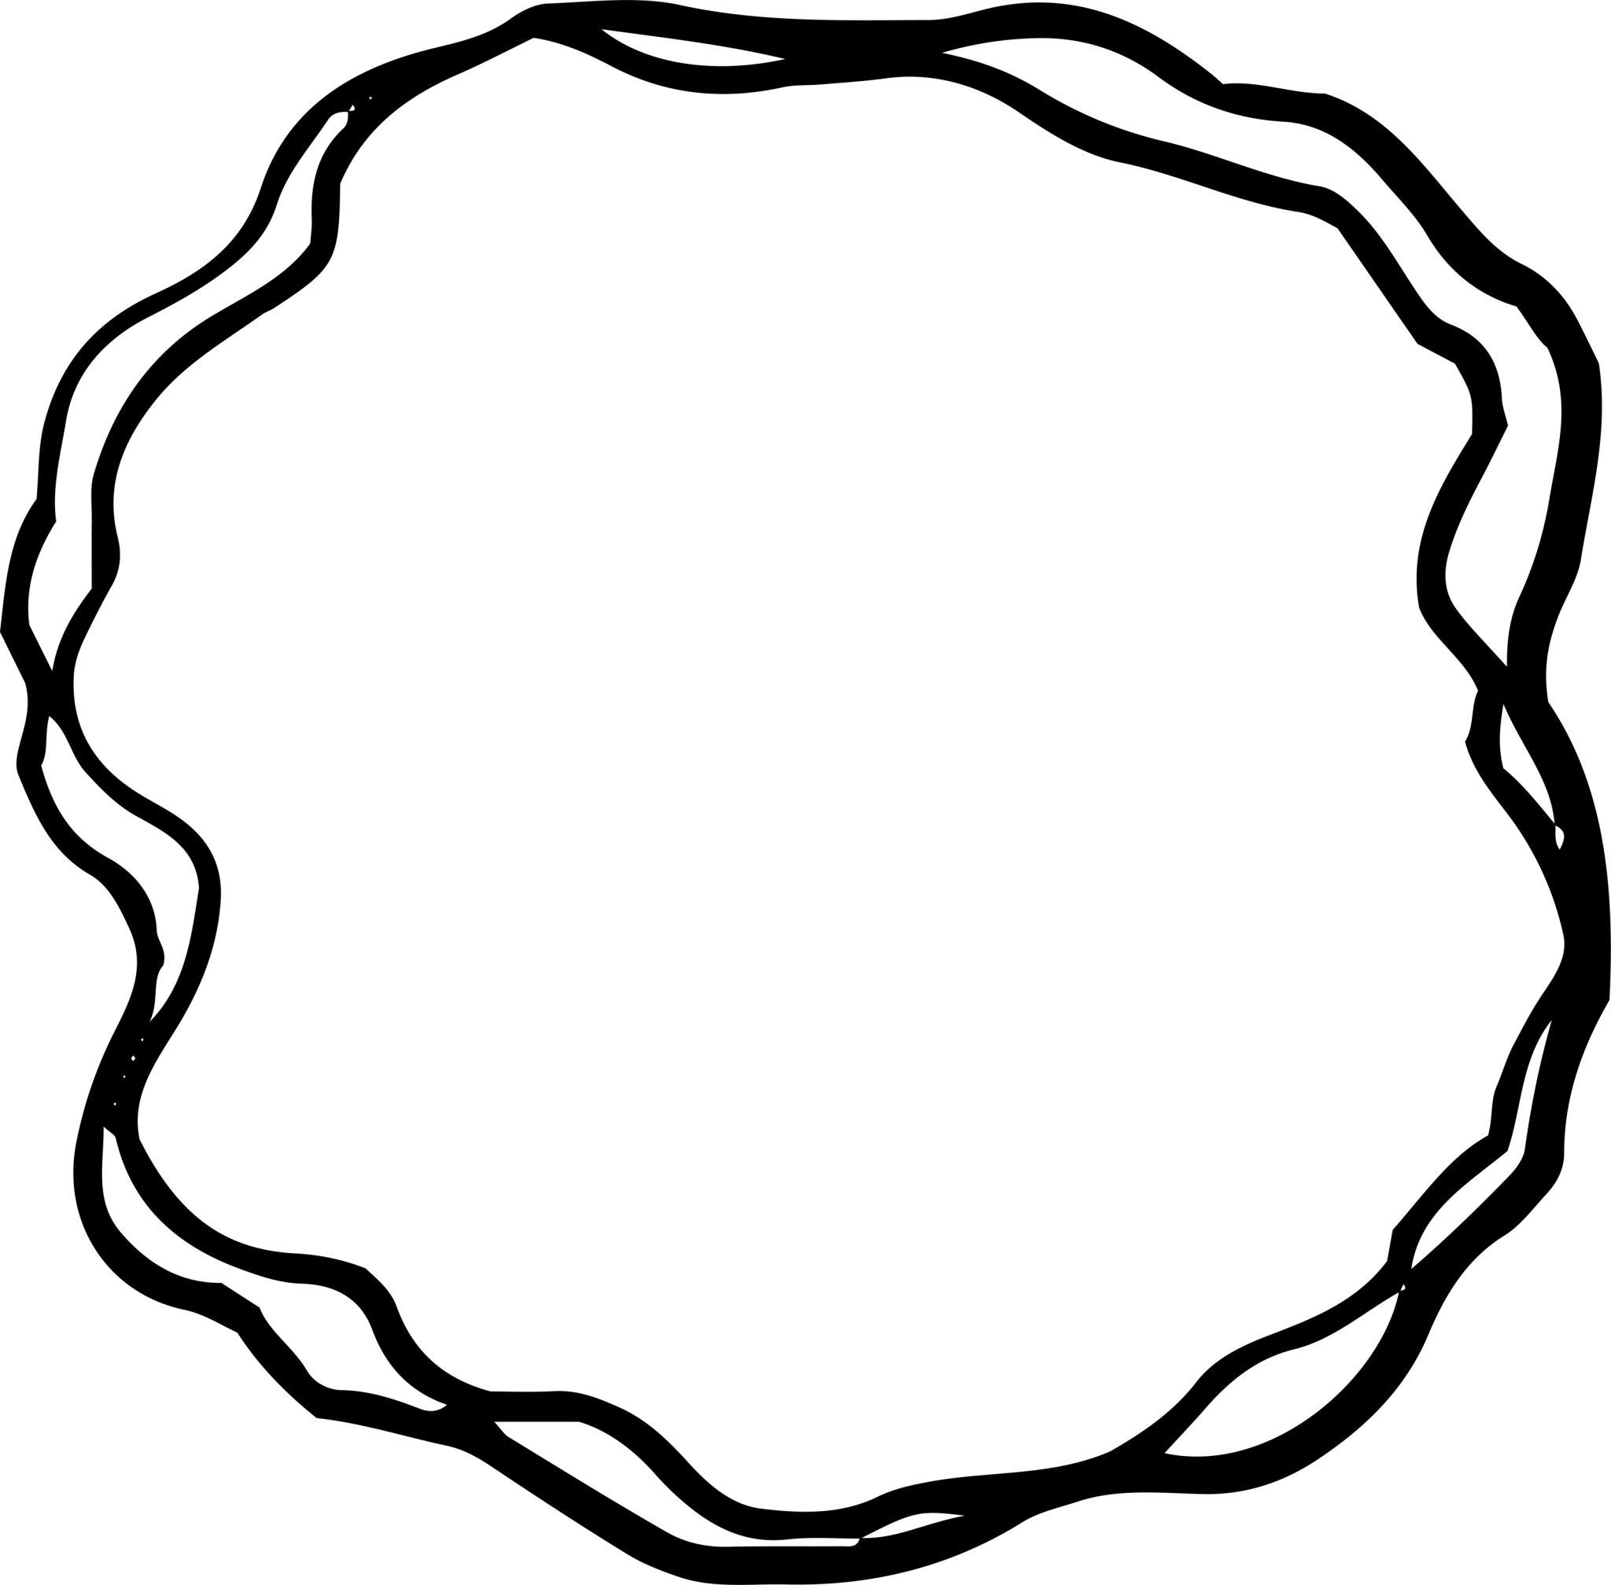
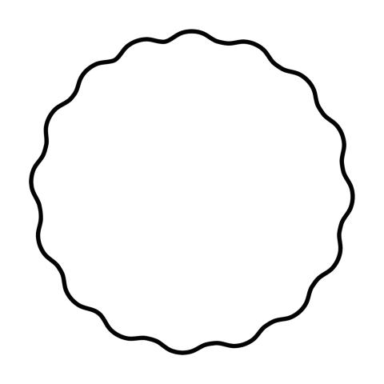
The waves may have varying:
- Amplitude.
- Spacing.
- Frequency.
- Curvature.

5. Circle–Lobed Freeform Closed Shapes
# Source: AI Source: Provided by: [Data Path: Persons Table -> ID Column: 1, Name_En Column: Motasem Essam] -> From: [ChatGPT] on [7/25/2026]
A circular component is combined with freely designed rounded lobes.
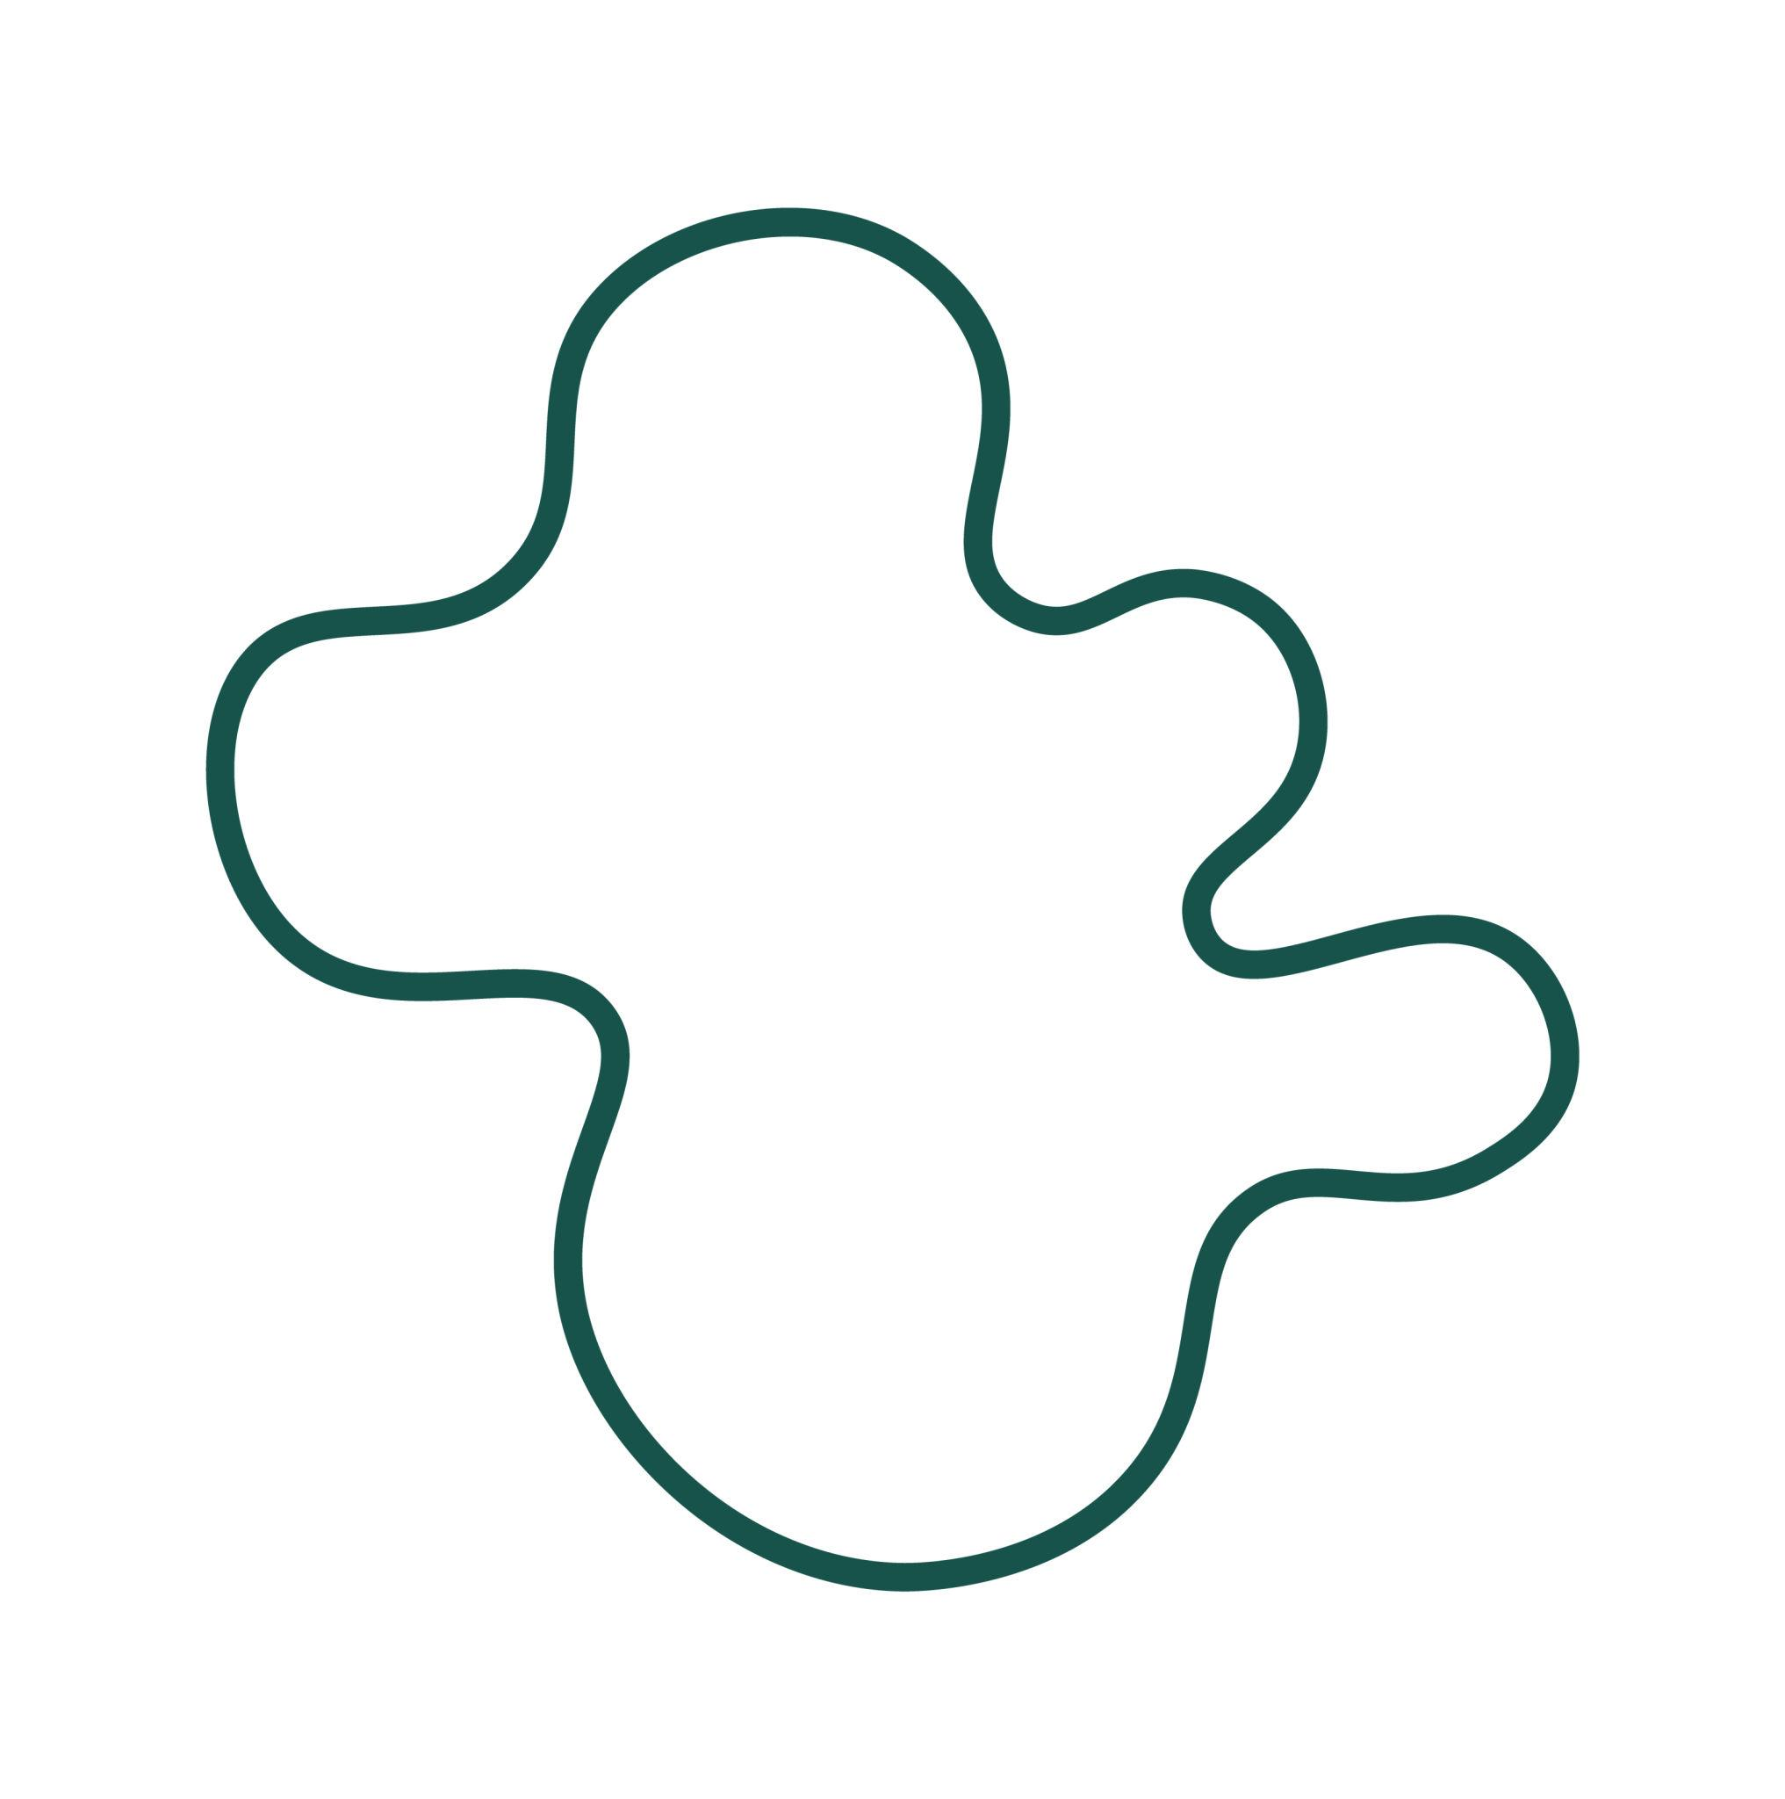
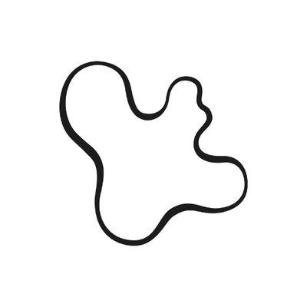
The lobes do not have to be equal in size or spacing.

6. Circle–Bulging Freeform Closed Shapes
# Source: AI Source: Provided by: [Data Path: Persons Table -> ID Column: 1, Name_En Column: Motasem Essam] -> From: [ChatGPT] on [7/25/2026]
The boundary contains a circular portion and one or more freely designed outward bulges.
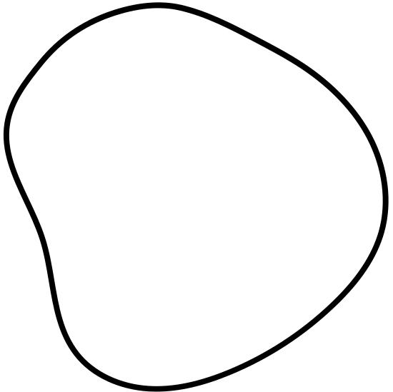
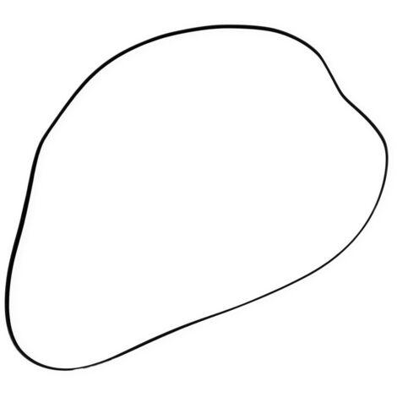
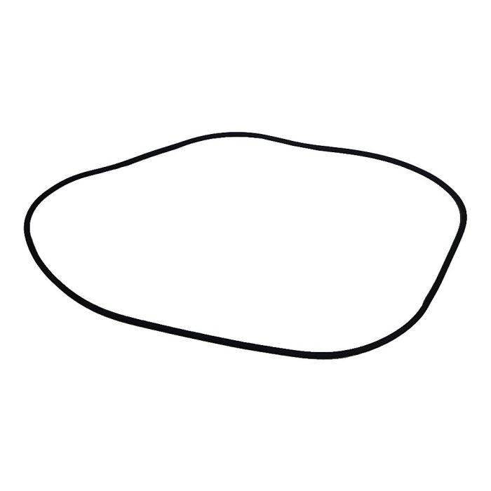
This type is useful for shapes that transition from a precise circular section to an irregular curved section.

7. Circle–Indented Freeform Closed Shapes
# Source: AI Source: Provided by: [Data Path: Persons Table -> ID Column: 1, Name_En Column: Motasem Essam] -> From: [ChatGPT] on [7/25/2026]
A circular portion is combined with an inward freeform indentation.
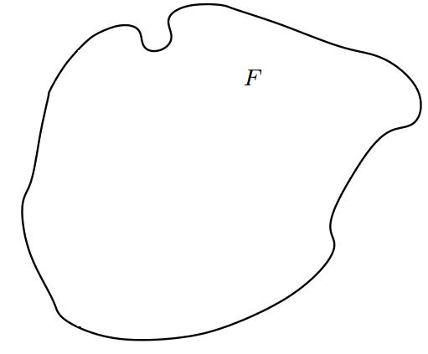
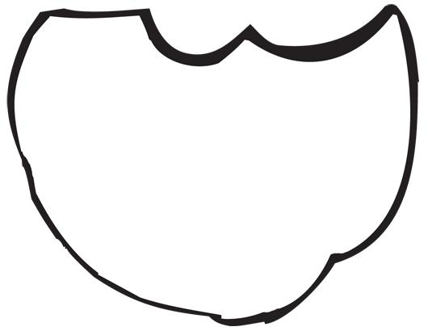
Depending on the depth of the indentation, the resulting shape can be concave.

8. Asymmetric Circular–Freeform Closed Shapes
# Source: AI Source: Provided by: [Data Path: Persons Table -> ID Column: 1, Name_En Column: Motasem Essam] -> From: [ChatGPT] on [7/25/2026]
The circular and freeform portions are arranged without regular symmetry.
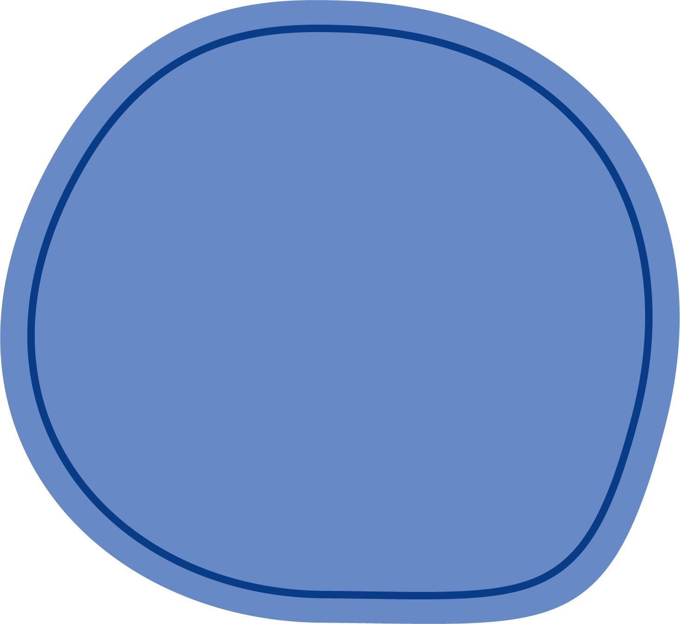
The shape may have different:
- Curvatures.
- Widths.
- Bulges.
- Arc lengths.
- Freeform control points.

9. Symmetric Circular–Freeform Closed Shapes
# Source: AI Source: Provided by: [Data Path: Persons Table -> ID Column: 1, Name_En Column: Motasem Essam] -> From: [ChatGPT] on [7/25/2026]
The freeform portions are deliberately arranged so that the complete shape retains an axis of symmetry.
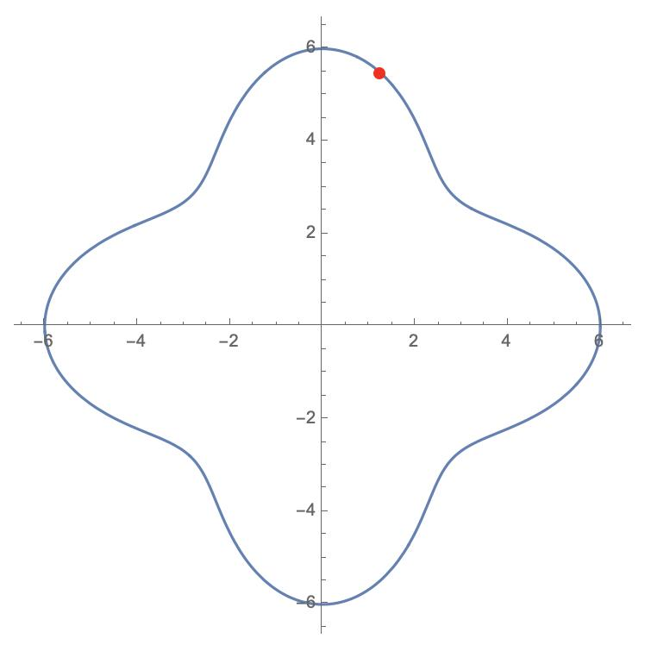
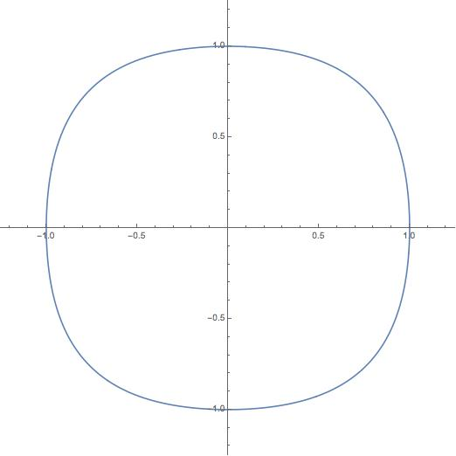
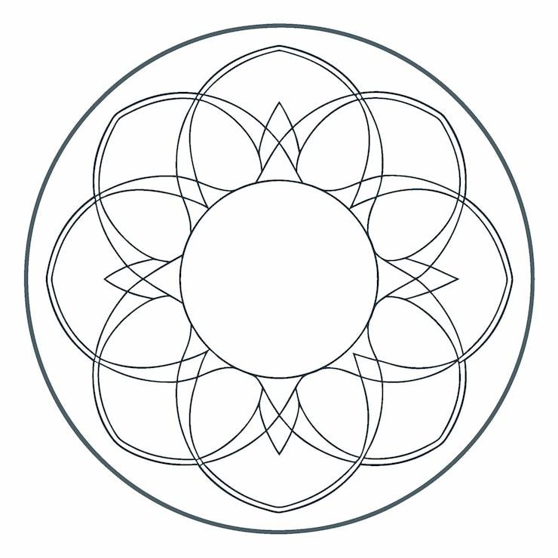
This demonstrates that:
$$\boxed{\text{Freeform}⇏\text{Asymmetric}}$$
A curve can be freely designed and still be symmetric.

10. Irregular Circular–Freeform Closed Shapes
# Source: AI Source: Provided by: [Data Path: Persons Table -> ID Column: 1, Name_En Column: Motasem Essam] -> From: [ChatGPT] on [7/25/2026]
These combine circular portions with highly irregular freeform curves.
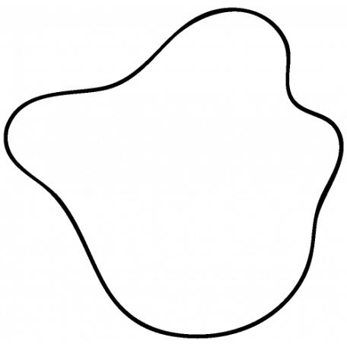
This is the broadest subtype and may contain several circular and freeform components.

Circular–Freeform vs. Circular–Organic
# Source: AI Source: Provided by: [Data Path: Persons Table -> ID Column: 1, Name_En Column: Motasem Essam] -> From: [ChatGPT] on [7/25/2026]
These categories can overlap, but they are based on different properties.
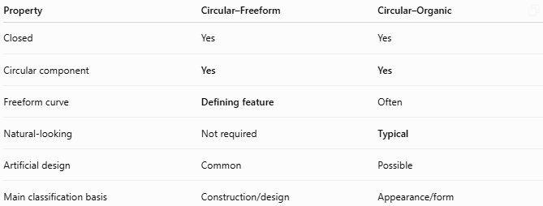
Property | Circular–Freeform | Circular–Organic
Closed | Yes | Yes
Circular component | Yes | Yes
Freeform curve | Defining feature | Often
Natural-looking | Not required | Typical
Artificial design | Common | Possible
Main classification basis | Construction/design | Appearance/form
For example:
Circular arc + abstract Bézier curve
→ Circular–Freeform Closed Shape
while:
Circular arc + leaf-like natural curve
→ Circular–Organic Closed Shape
A shape can be both:
[
\boxed{
\text{Circular}
+
\text{Freeform}
+
\text{Organic-Looking}
}
]

Circular–Freeform vs. Polygon–Freeform
# Source: AI Source: Provided by: [Data Path: Persons Table -> ID Column: 1, Name_En Column: Motasem Essam] -> From: [ChatGPT] on [7/25/2026]
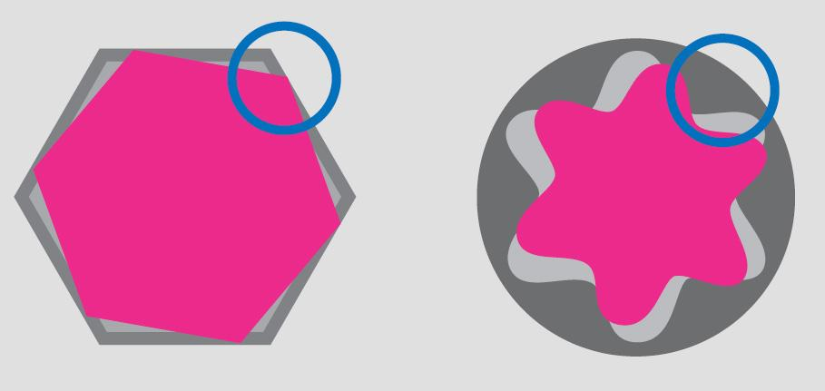
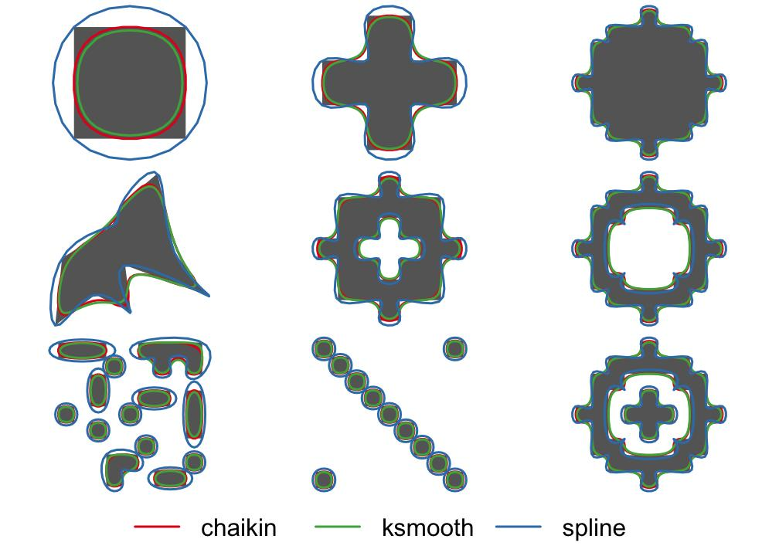
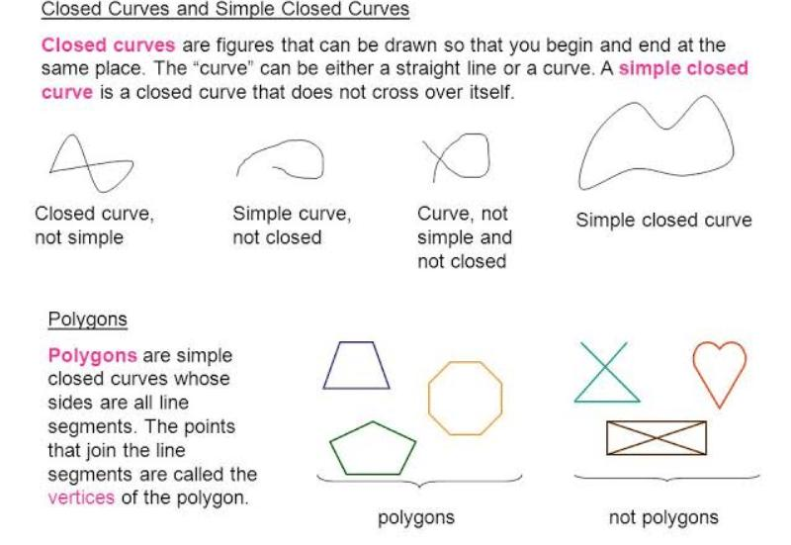
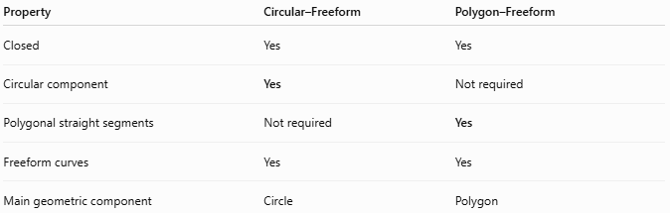
Property | Circular–Freeform | Polygon–Freeform
Closed | Yes | Yes
Circular component | Yes | Not required
Polygonal straight segments | Not required | Yes
Freeform curves | Yes | Yes
Main geometric component | Circle | Polygon
Therefore:
$$\boxed{\text{Circular–Freeform}=\text{Circular}+\text{Freeform}}$$
while:
$$\boxed{\text{Polygon–Freeform}=\text{Polygon}+\text{Freeform}}$$

Circular–Freeform vs. Pure Circular Shapes
# Source: AI Source: Provided by: [Data Path: Persons Table -> ID Column: 1, Name_En Column: Motasem Essam] -> From: [ChatGPT] on [7/25/2026]
A pure circular shape has only circular geometry.
$$\boxed{\text{Pure Circular Shape}=\text{Circular Boundary}}$$
A Circular–Freeform shape contains an additional freely designed curve:
$$\boxed{\text{Circular–Freeform}=\text{Circular Boundary}+\text{Freeform Boundary}}$$

Area
# Source: AI Source: Provided by: [Data Path: Persons Table -> ID Column: 1, Name_En Column: Motasem Essam] -> From: [ChatGPT] on [7/25/2026]
The shape is a composite closed region.
Its area can be determined by decomposing it into circular and freeform portions:
$$\boxed{A_{\text{total}}=A_{\text{circular}}±A_{\text{freeform}}}$$
For a simple circular component:
$$A_{\text{circle}}=πr^{2}$$
For a general freeform component, numerical integration or computational geometry may be required.
For a parametric closed boundary:
$$x=x\left(t\right), y=y\left(t\right)$$
the enclosed area can be expressed as:
$$\boxed{A=\frac{1}{2}\oint{\left(x,dy-y,dx\right)}}$$

Perimeter
# Source: AI Source: Provided by: [Data Path: Persons Table -> ID Column: 1, Name_En Column: Motasem Essam] -> From: [ChatGPT] on [7/25/2026]
The perimeter contains both circular and freeform curved portions:
$$\boxed{P=L_{\text{circular}}+L_{\text{freeform}}}$$
For a circular arc:
$$L_{\text{arc}}=rθ$$
where $θ$ is in radians.
The freeform section requires an arc-length calculation or numerical measurement.

Key Points
# Source: AI Source: Provided by: [Data Path: Persons Table -> ID Column: 1, Name_En Column: Motasem Essam] -> From: [ChatGPT] on [7/25/2026]
A Circular–Freeform Closed Shape is:
$$\boxed{\text{Closed}+\text{Circular Component}+\text{Freely Designed Curved Component}}$$
It:
- Has a completely closed boundary.
- Contains at least one circular portion.
- Contains at least one freeform curved portion.
- Does not require the freeform curve to be circular or elliptical.
- May be convex or concave.
- May be symmetric or asymmetric.
- May be regular-looking or highly irregular.
- Can be constructed using Bézier curves, splines, CAD, or vector paths.

Conclusion
# Source: AI Source: Provided by: [Data Path: Persons Table -> ID Column: 1, Name_En Column: Motasem Essam] -> From: [ChatGPT] on [7/25/2026]
Circular–Freeform Closed Shapes are mixed closed shapes that combine precisely defined circular geometry with freely designed curved geometry. Their main distinction from Circular–Organic Closed Shapes is that freeform describes how the non-circular curve is constructed or controlled, while organic describes its visual or natural-looking character. A single shape may belong to both classifications when a circular component is combined with a freeform curve that also has an organic appearance.

